Generate report giving state-wise breakup of number of customers

.mode column

.import “C:/mydocs/ai academy/Capstone Project1_Marketing Data/Marketing_Campaign_P1/Customer_and_bank details_p1.csv” cust

.schema cust

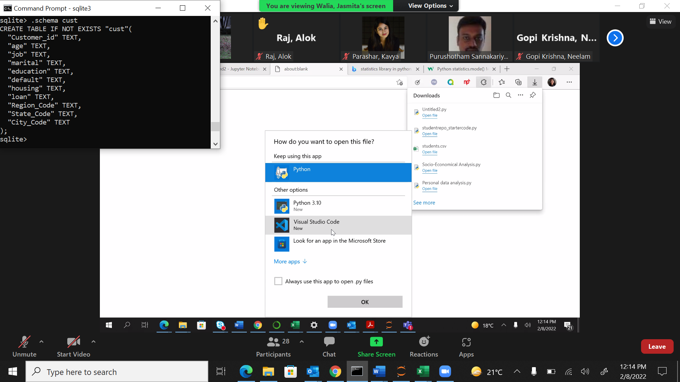

CREATE TABLE IF NOT EXISTS "cust"(

"Customer_id" TEXT,

"age" TEXT,

"job" TEXT,

"marital" TEXT,

"education" TEXT,

"default" TEXT,

"housing" TEXT,

"loan" TEXT,

"Region_Code" TEXT,

"State_Code" TEXT,

"City_Code" TEXT

);

.import “C:/mydocs/ai academy/Capstone Project1_Marketing Data/Marketing_Campaign_P1/State_Master.csv” state

.schema state

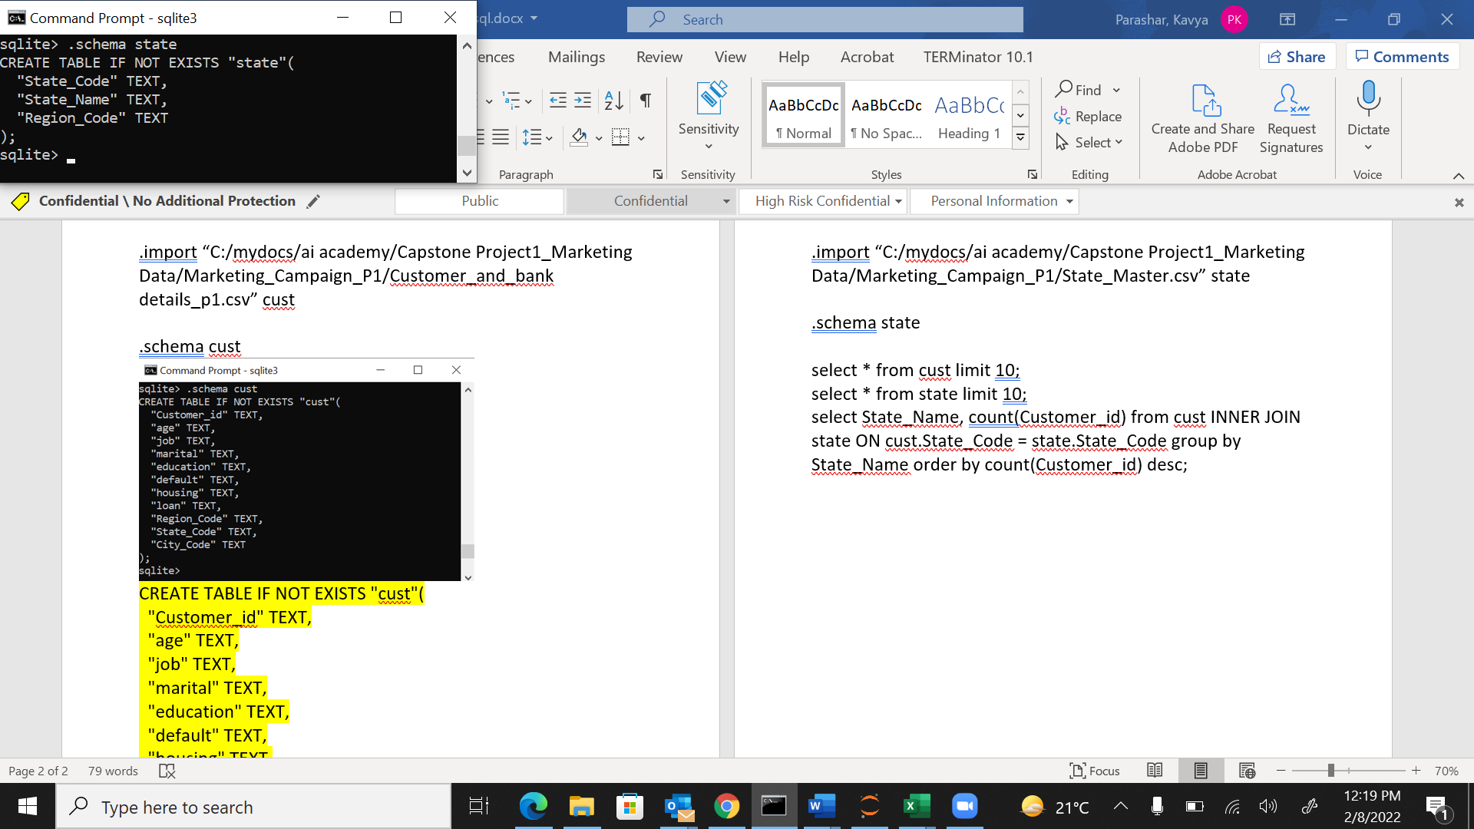

CREATE TABLE IF NOT EXISTS "state"(

"State_Code" TEXT,

"State_Name" TEXT,

"Region_Code" TEXT

);

select * from cust limit 10;

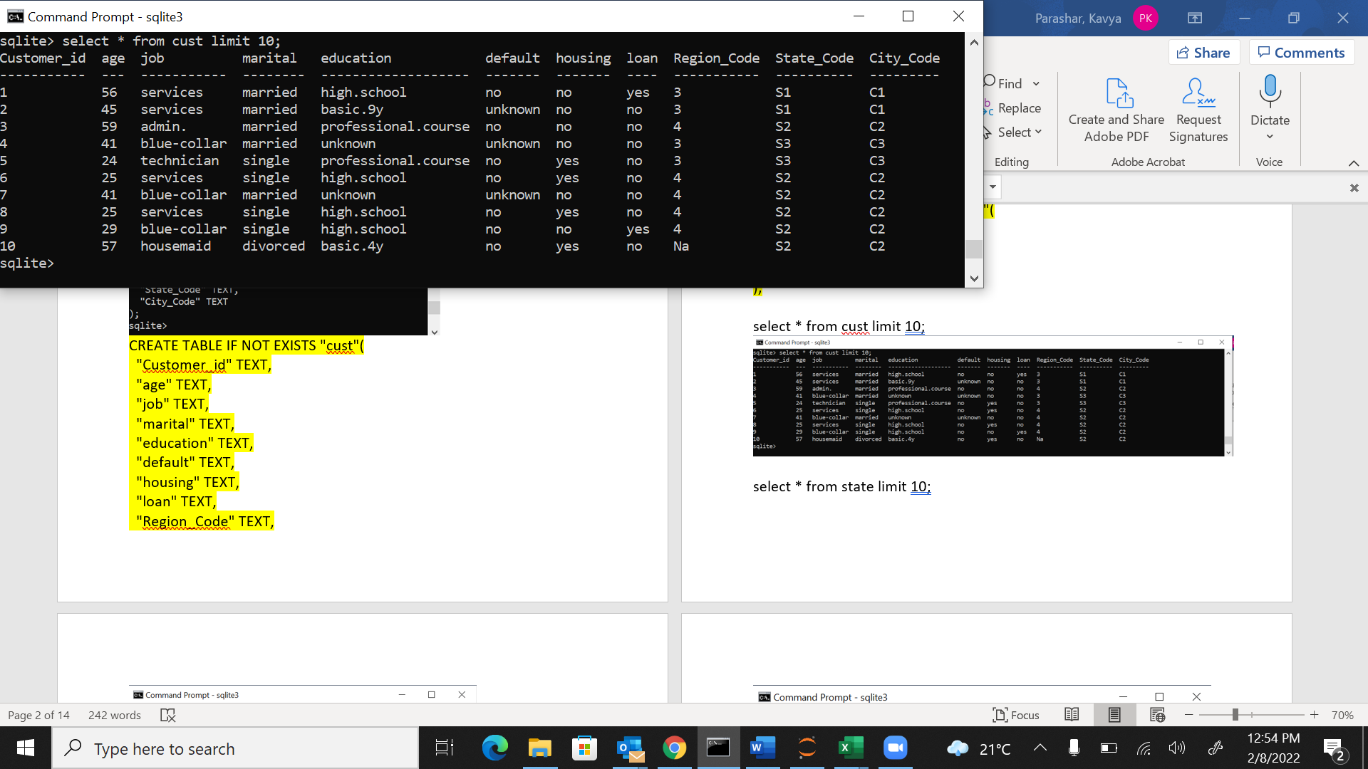

select * from state limit 10;

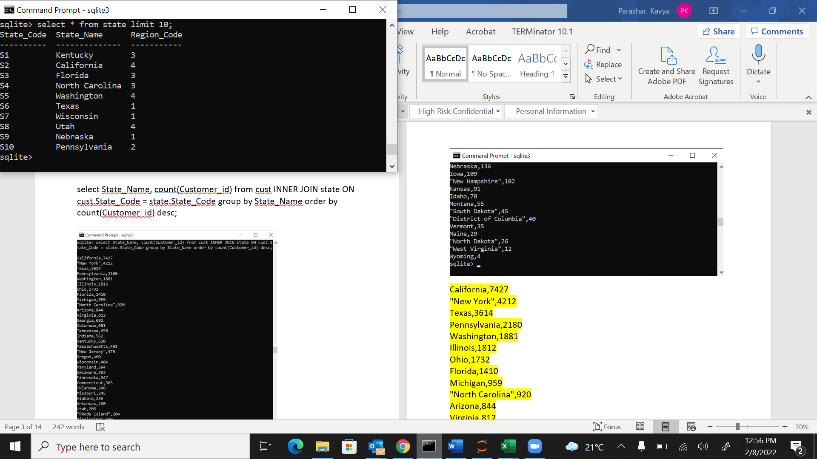

select State_Name, count(Customer_id) from cust INNER JOIN state ON cust.State_Code = state.State_Code group by State_Name order by count(Customer_id) desc;

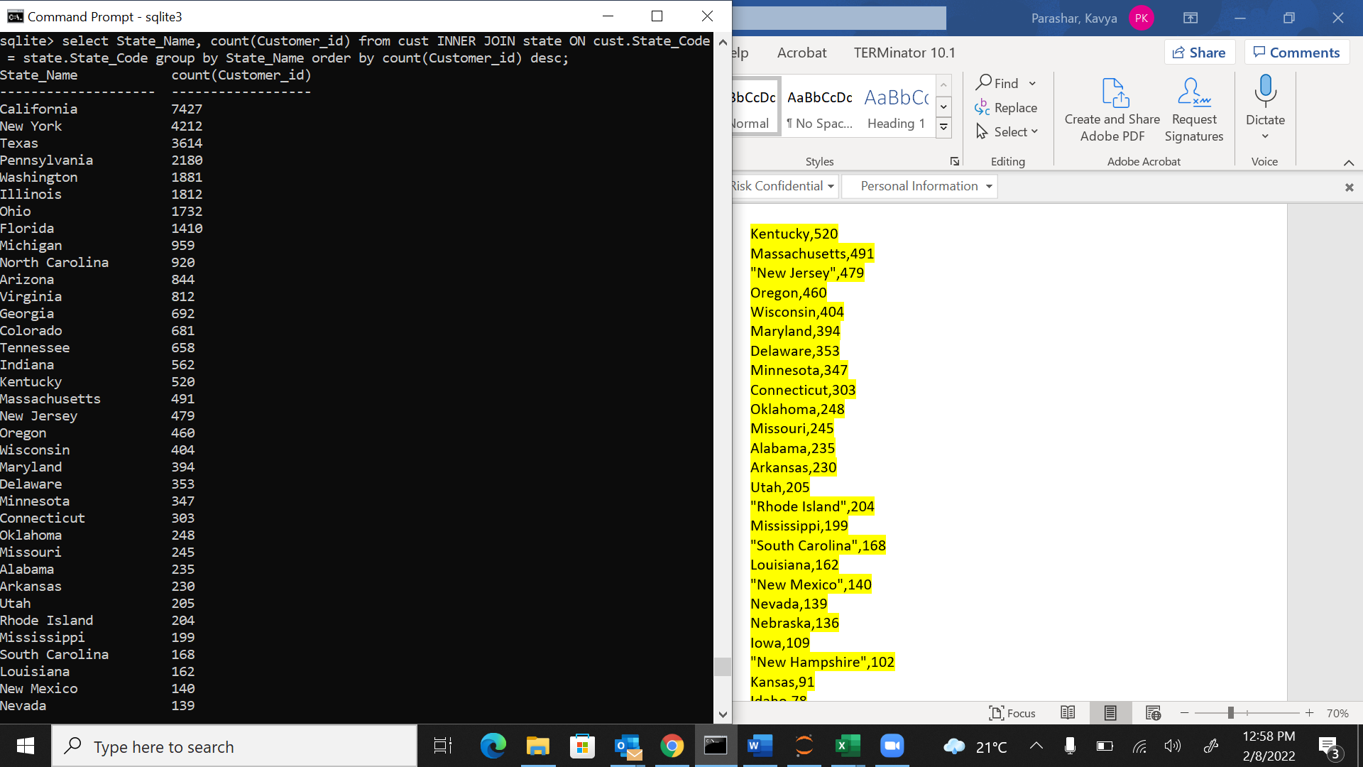

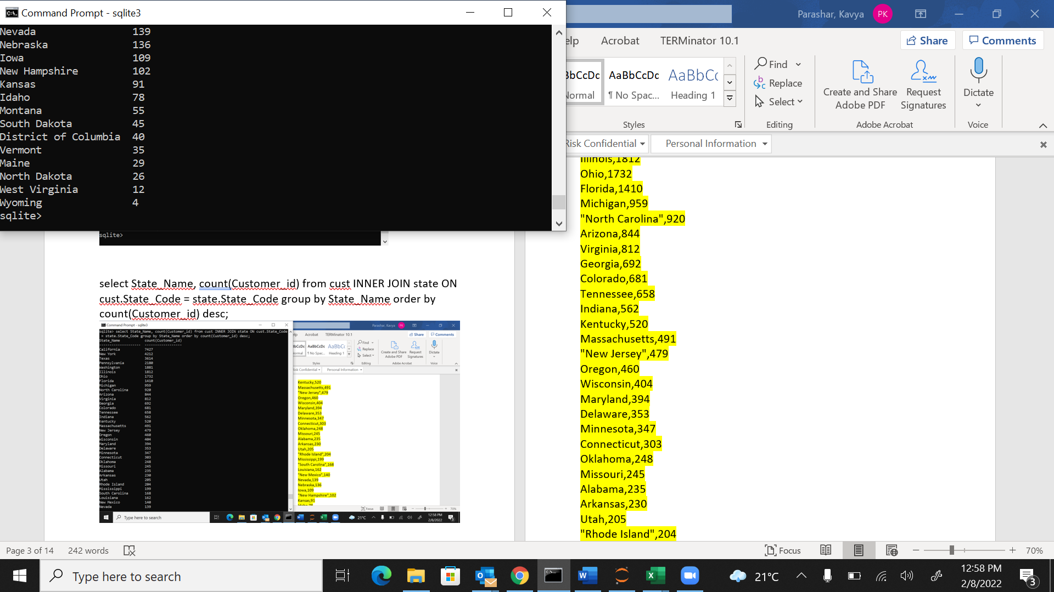

State_Name count(Customer_id)

-------------------- ------------------

California 7427

New York 4212

Texas 3614

Pennsylvania 2180

Washington 1881

Illinois 1812

Ohio 1732

Florida 1410

Michigan 959

North Carolina 920

Arizona 844

Virginia 812

Georgia 692

Colorado 681

Tennessee 658

Indiana 562

Kentucky 520

Massachusetts 491

New Jersey 479

Oregon 460

Wisconsin 404

Maryland 394

Delaware 353

Minnesota 347

Connecticut 303

Oklahoma 248

Missouri 245

Alabama 235

Arkansas 230

Utah 205

Rhode Island 204

Mississippi 199

South Carolina 168

Louisiana 162

New Mexico 140

Nevada 139

Nebraska 136

Iowa 109

New Hampshire 102

Kansas 91

Idaho 78

Montana 55

South Dakota 45

District of Columbia 40

Vermont 35

Maine 29

North Dakota 26

West Virginia 12

Wyoming 4

Generate report giving city-wise distribution of customers

.import “C:/mydocs/ai academy/Capstone Project1_Marketing Data/Marketing_Campaign_P1/Customer_and_bank details_p1.csv” cust

.schema cust



CREATE TABLE IF NOT EXISTS "cust"(

"Customer_id" TEXT,

"age" TEXT,

"job" TEXT,

"marital" TEXT,

"education" TEXT,

"default" TEXT,

"housing" TEXT,

"loan" TEXT,

"Region_Code" TEXT,

"State_Code" TEXT,

"City_Code" TEXT

);

.import “C:/mydocs/ai academy/Capstone Project1_Marketing Data/Marketing_Campaign_P1/State_Master.csv” state

.schema state



CREATE TABLE IF NOT EXISTS "state"(

"State_Code" TEXT,

"State_Name" TEXT,

"Region_Code" TEXT

);

select * from cust limit 10;



select * from state limit 10;



.import "C:/Users/kparashar/AI Academy/City_Master.csv" city

.schema city

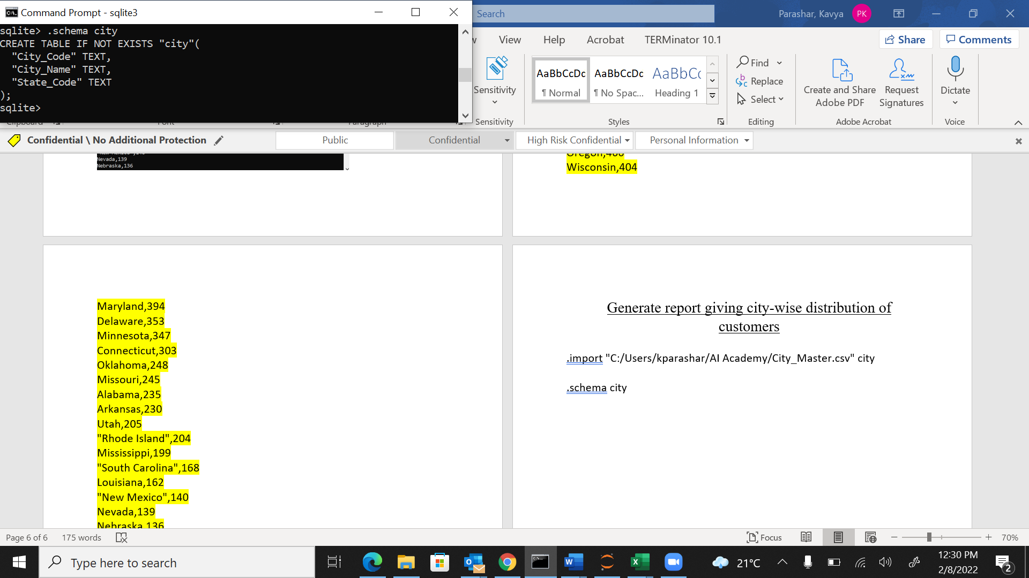

CREATE TABLE IF NOT EXISTS "city"(

"City_Code" TEXT,

"City_Name" TEXT,

"State_Code" TEXT

);

Select * from city limit 10;

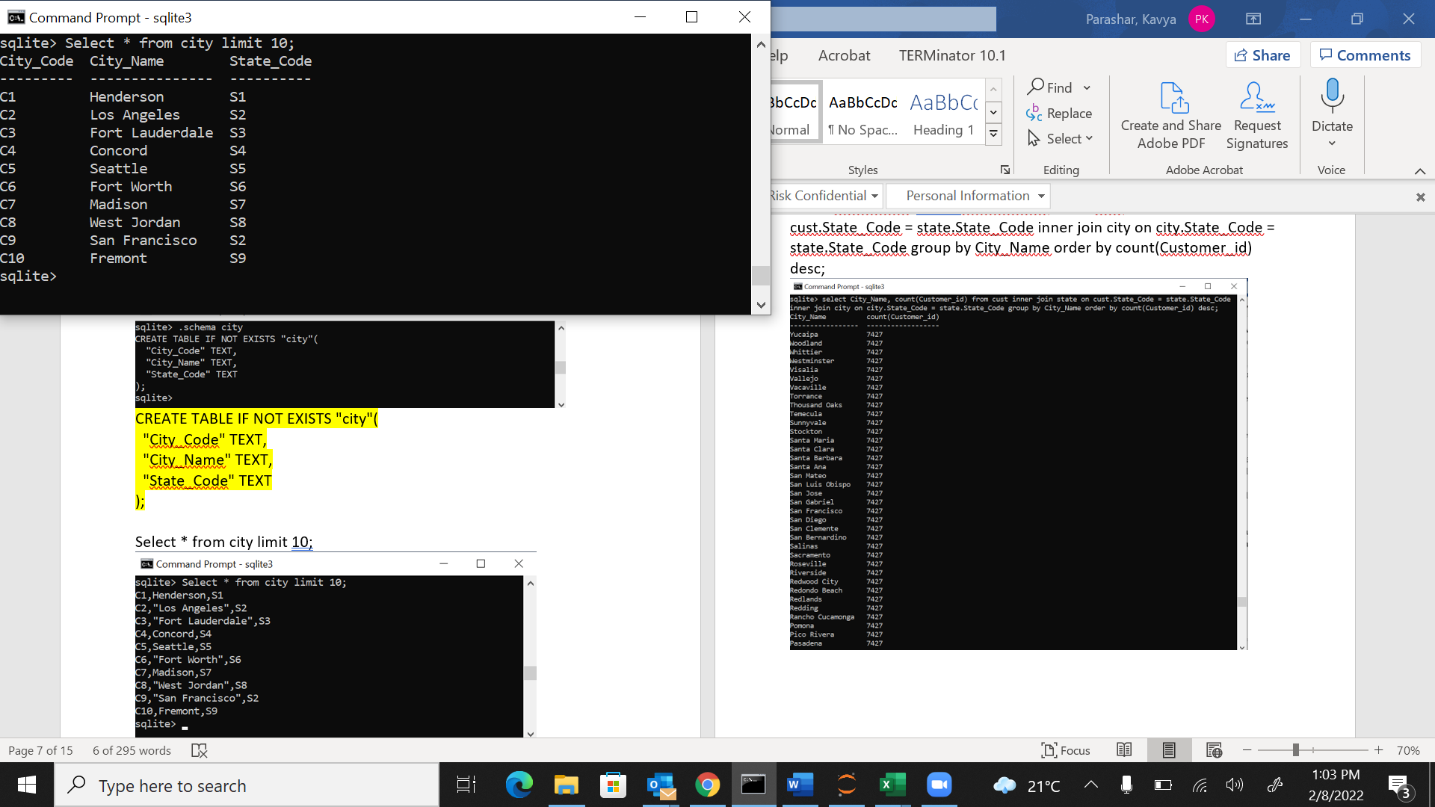

select City_Name, count(Customer_id) from cust inner join state on cust.State_Code = state.State_Code inner join city on city.State_Code = state.State_Code group by City_Name order by count(Customer_id) desc;

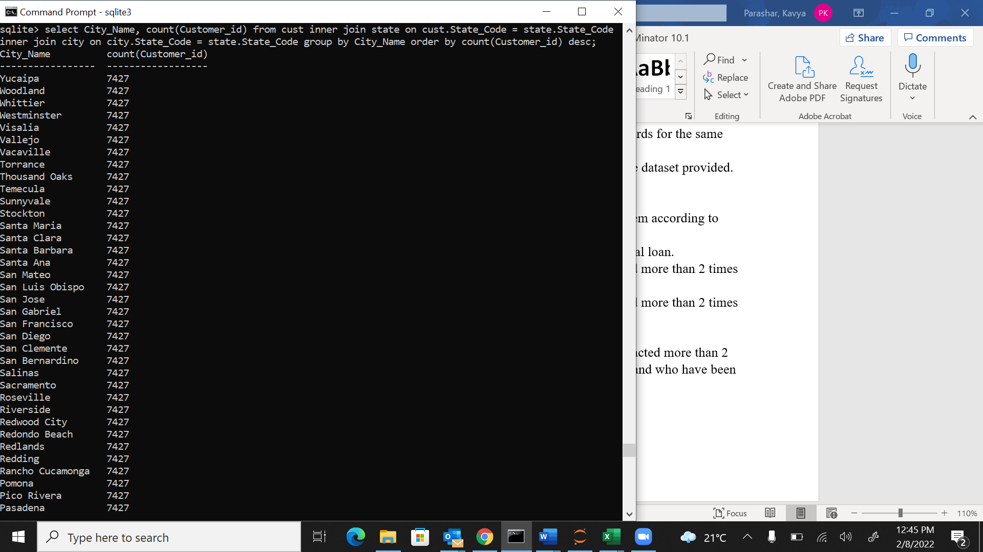

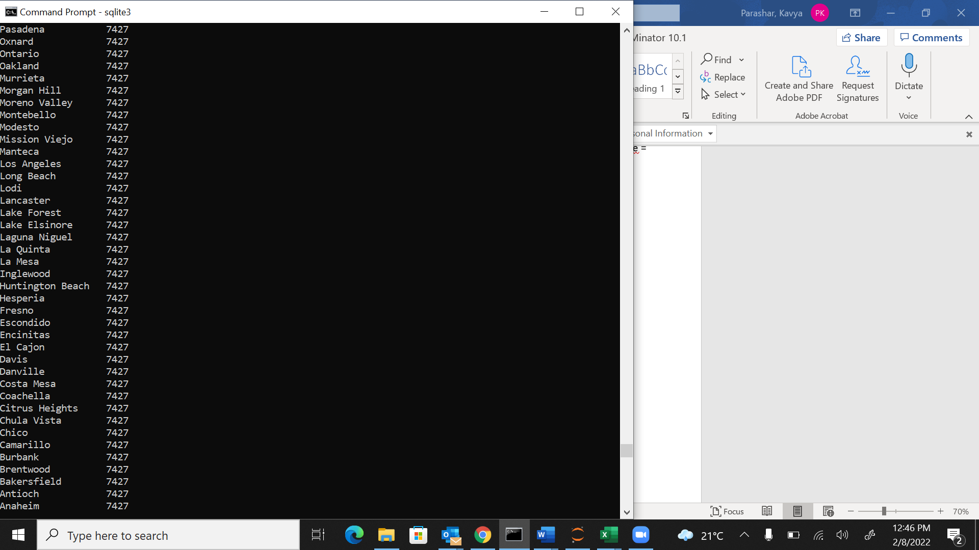

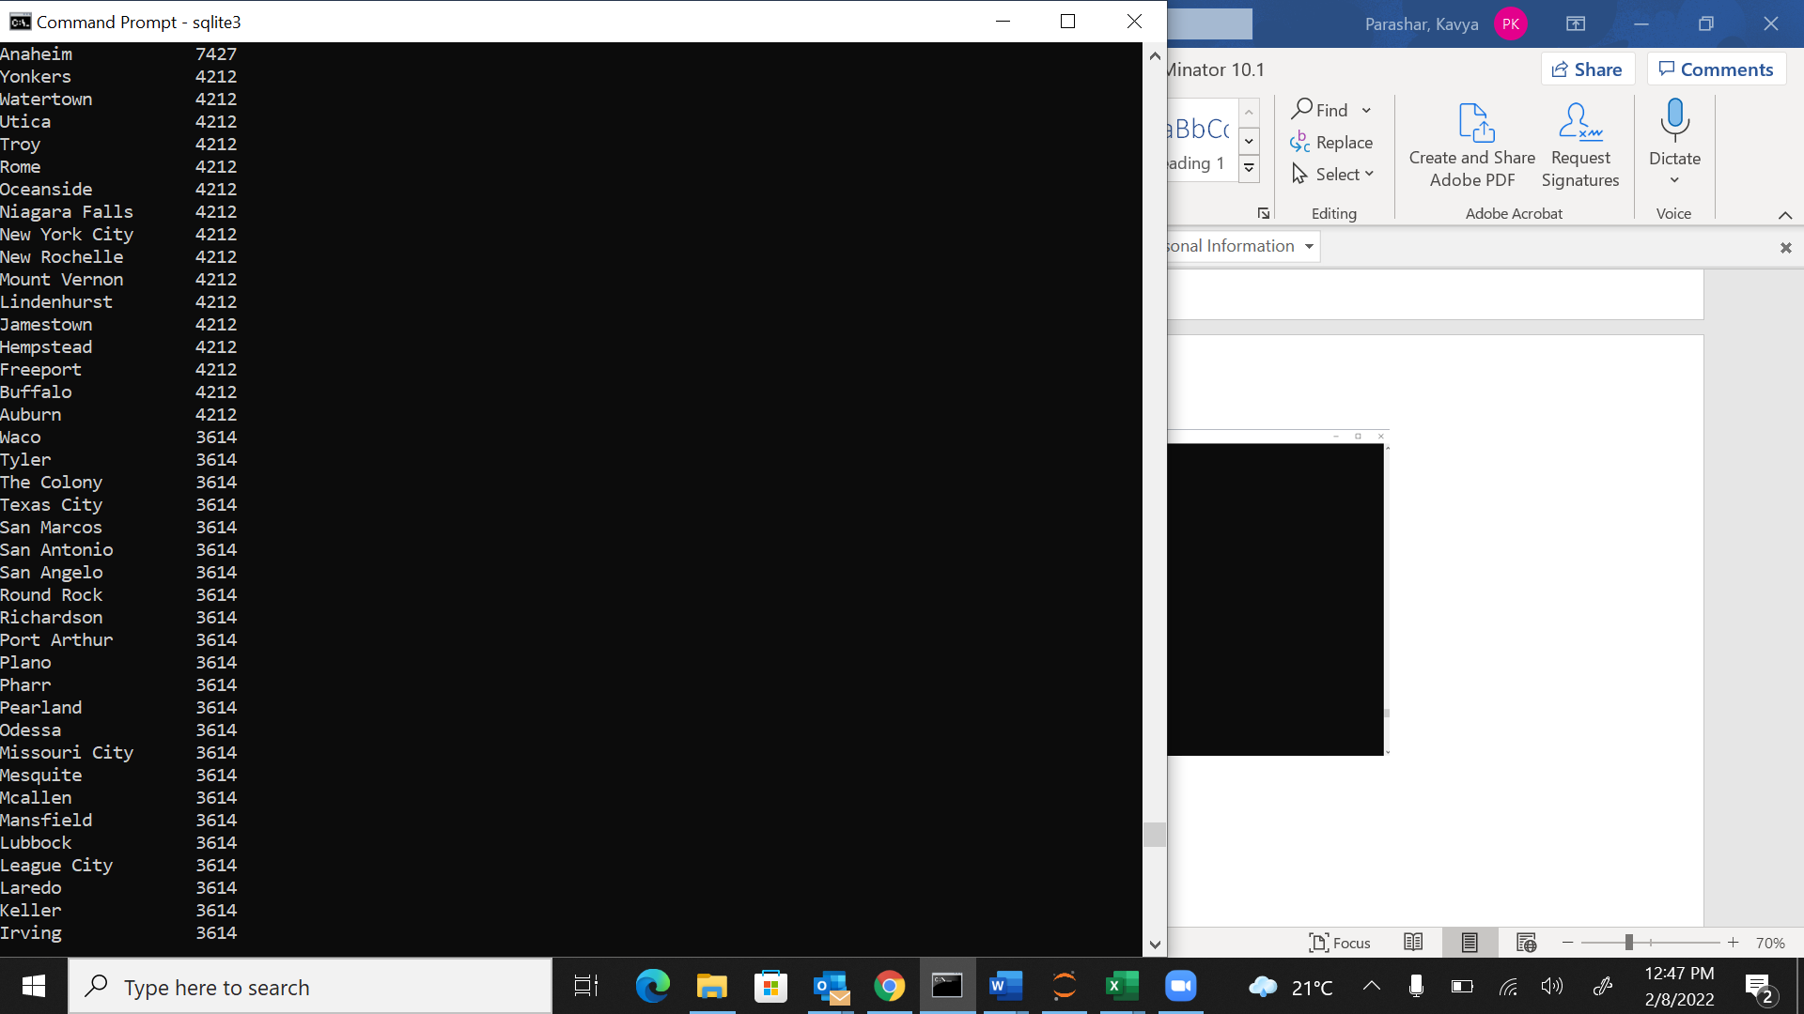

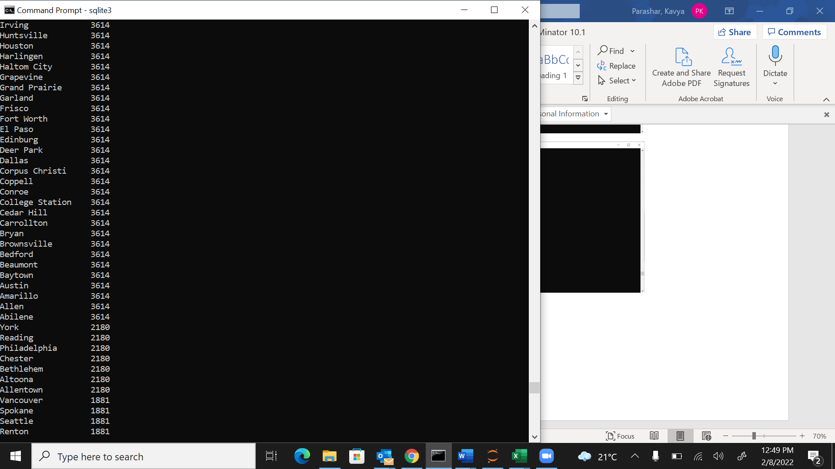

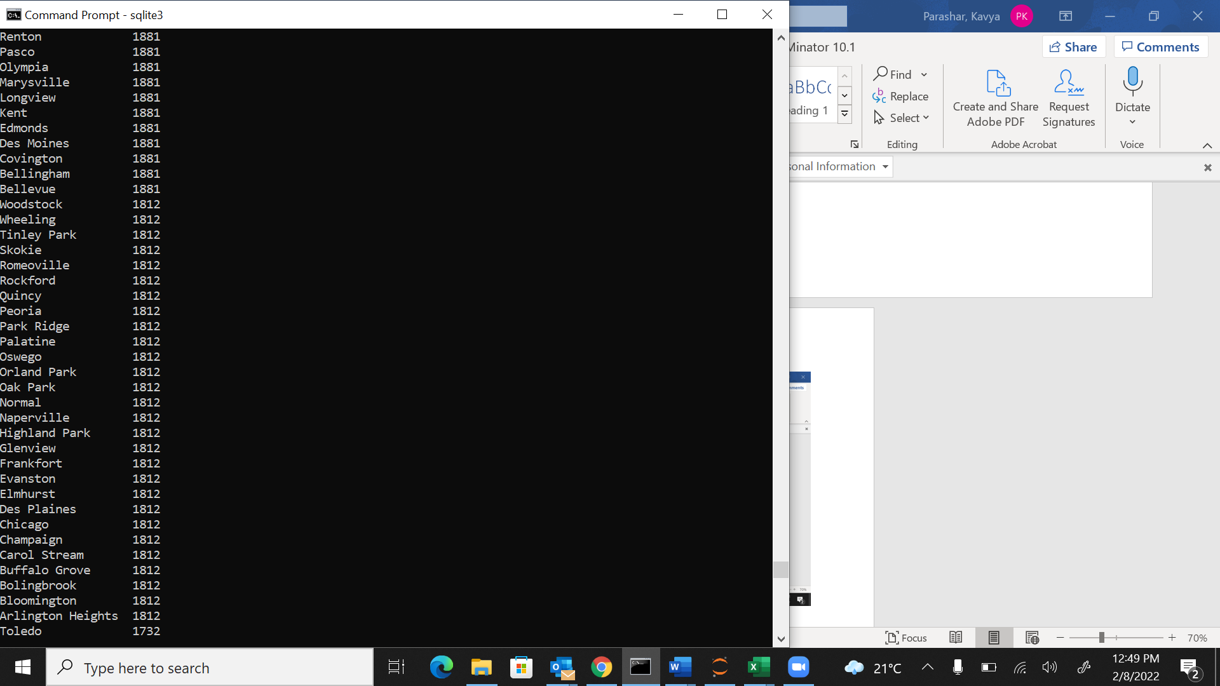

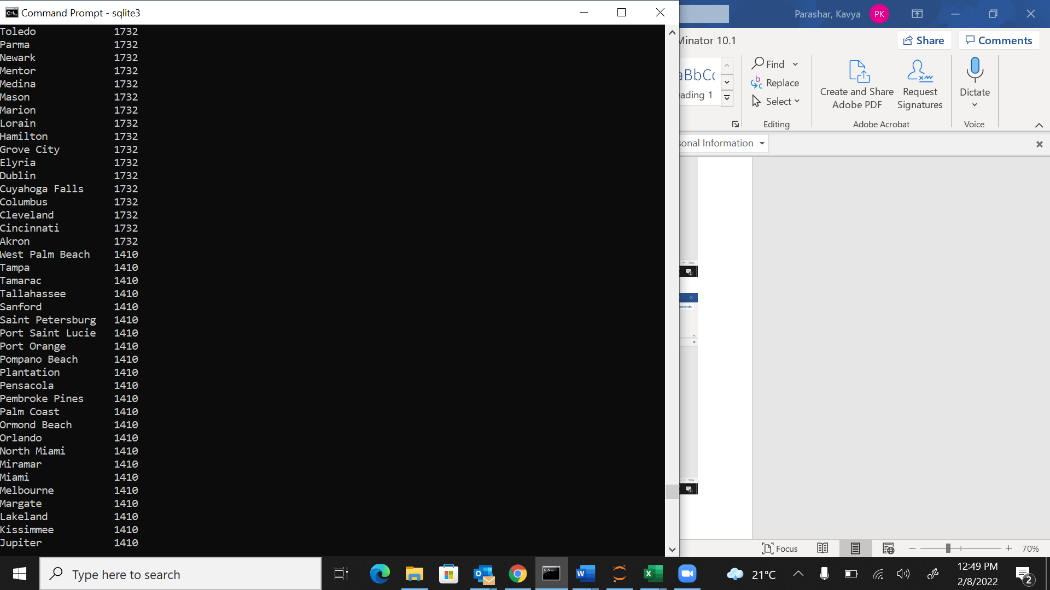

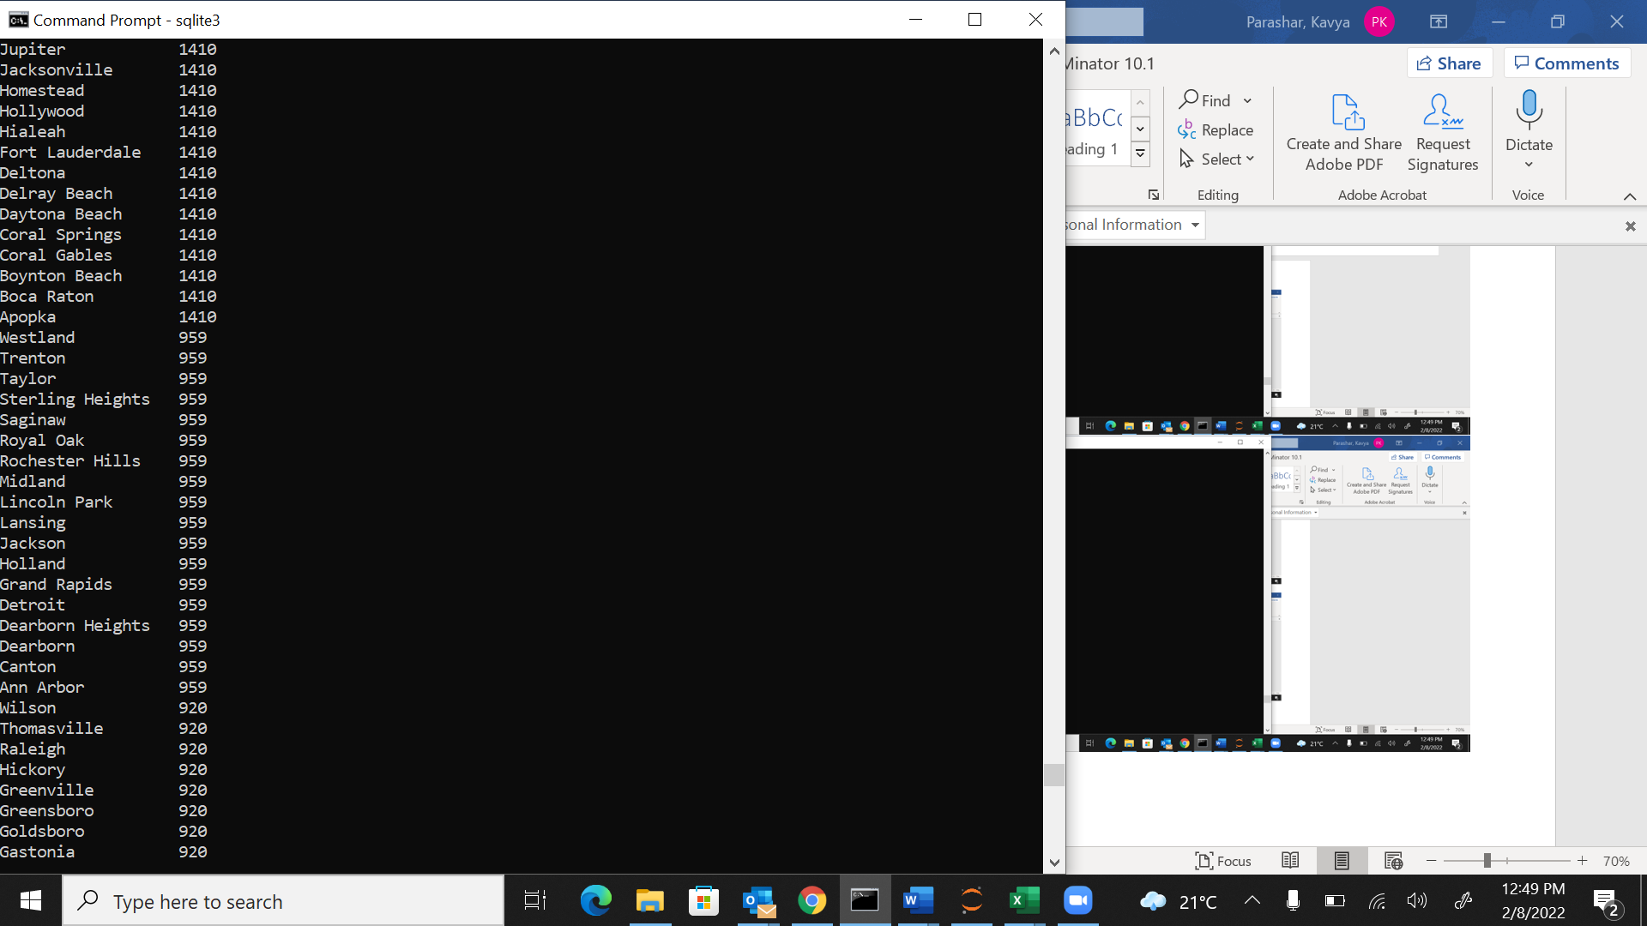

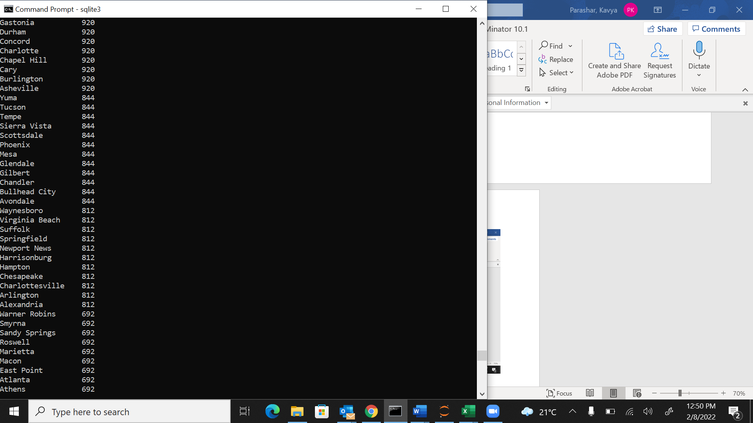

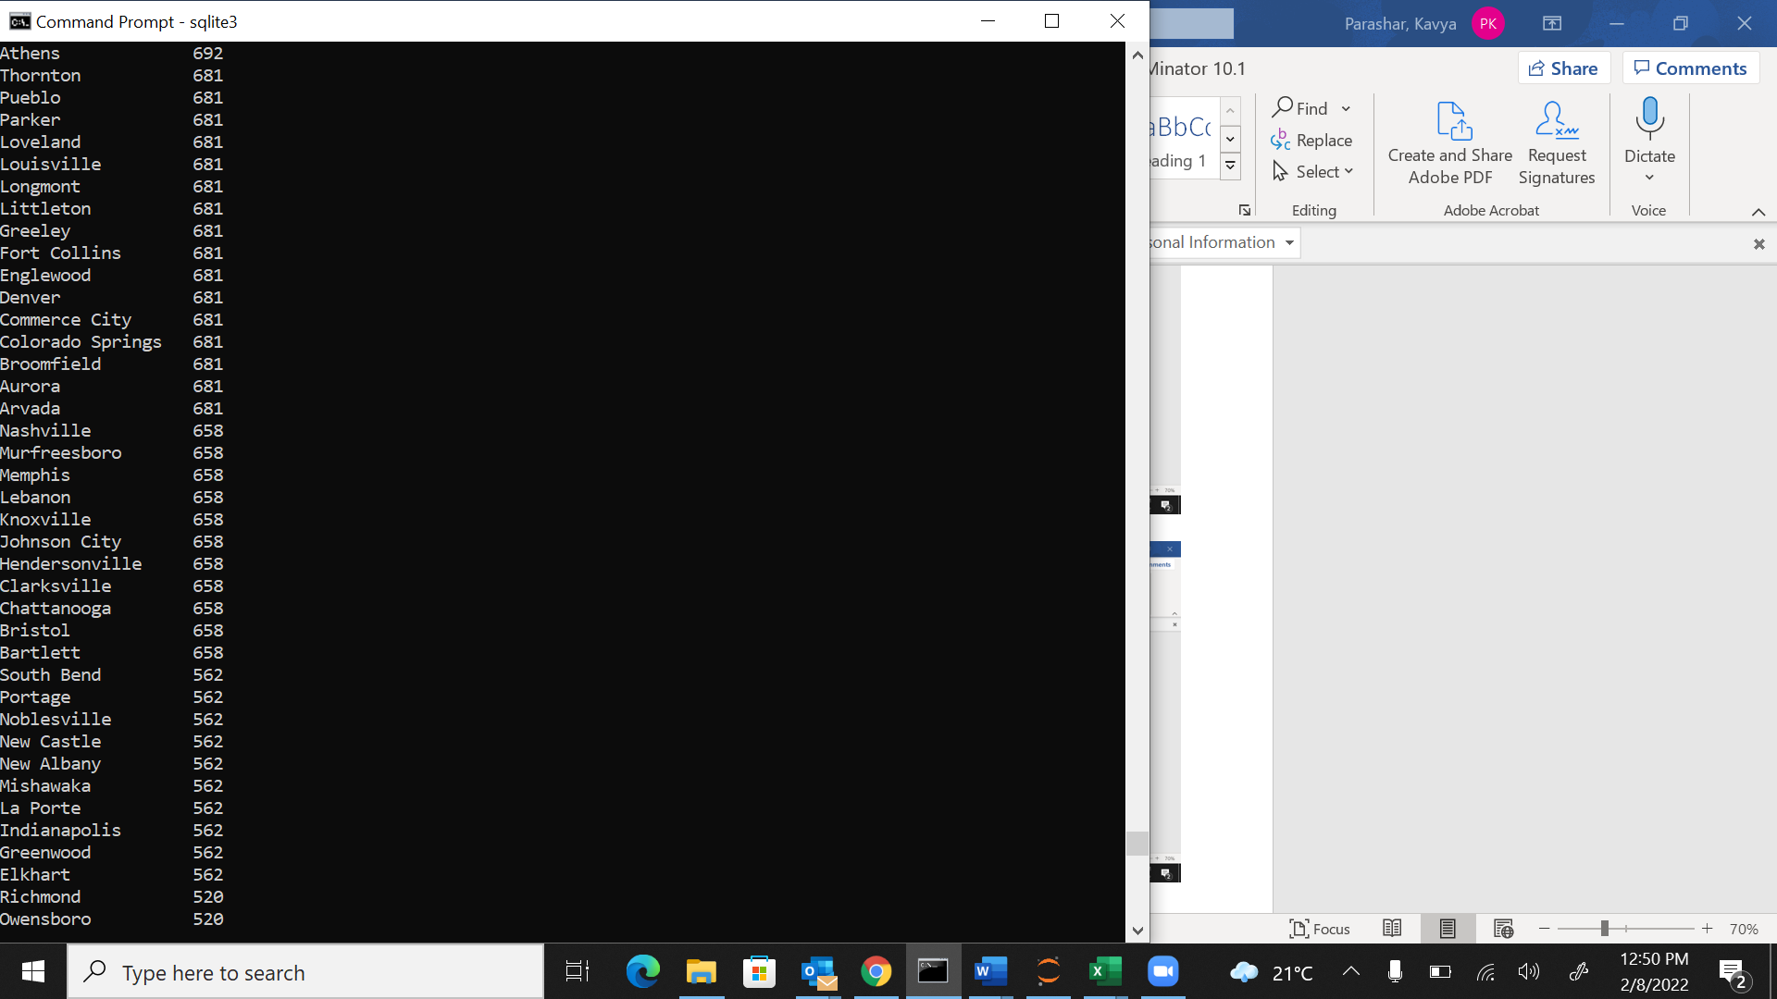

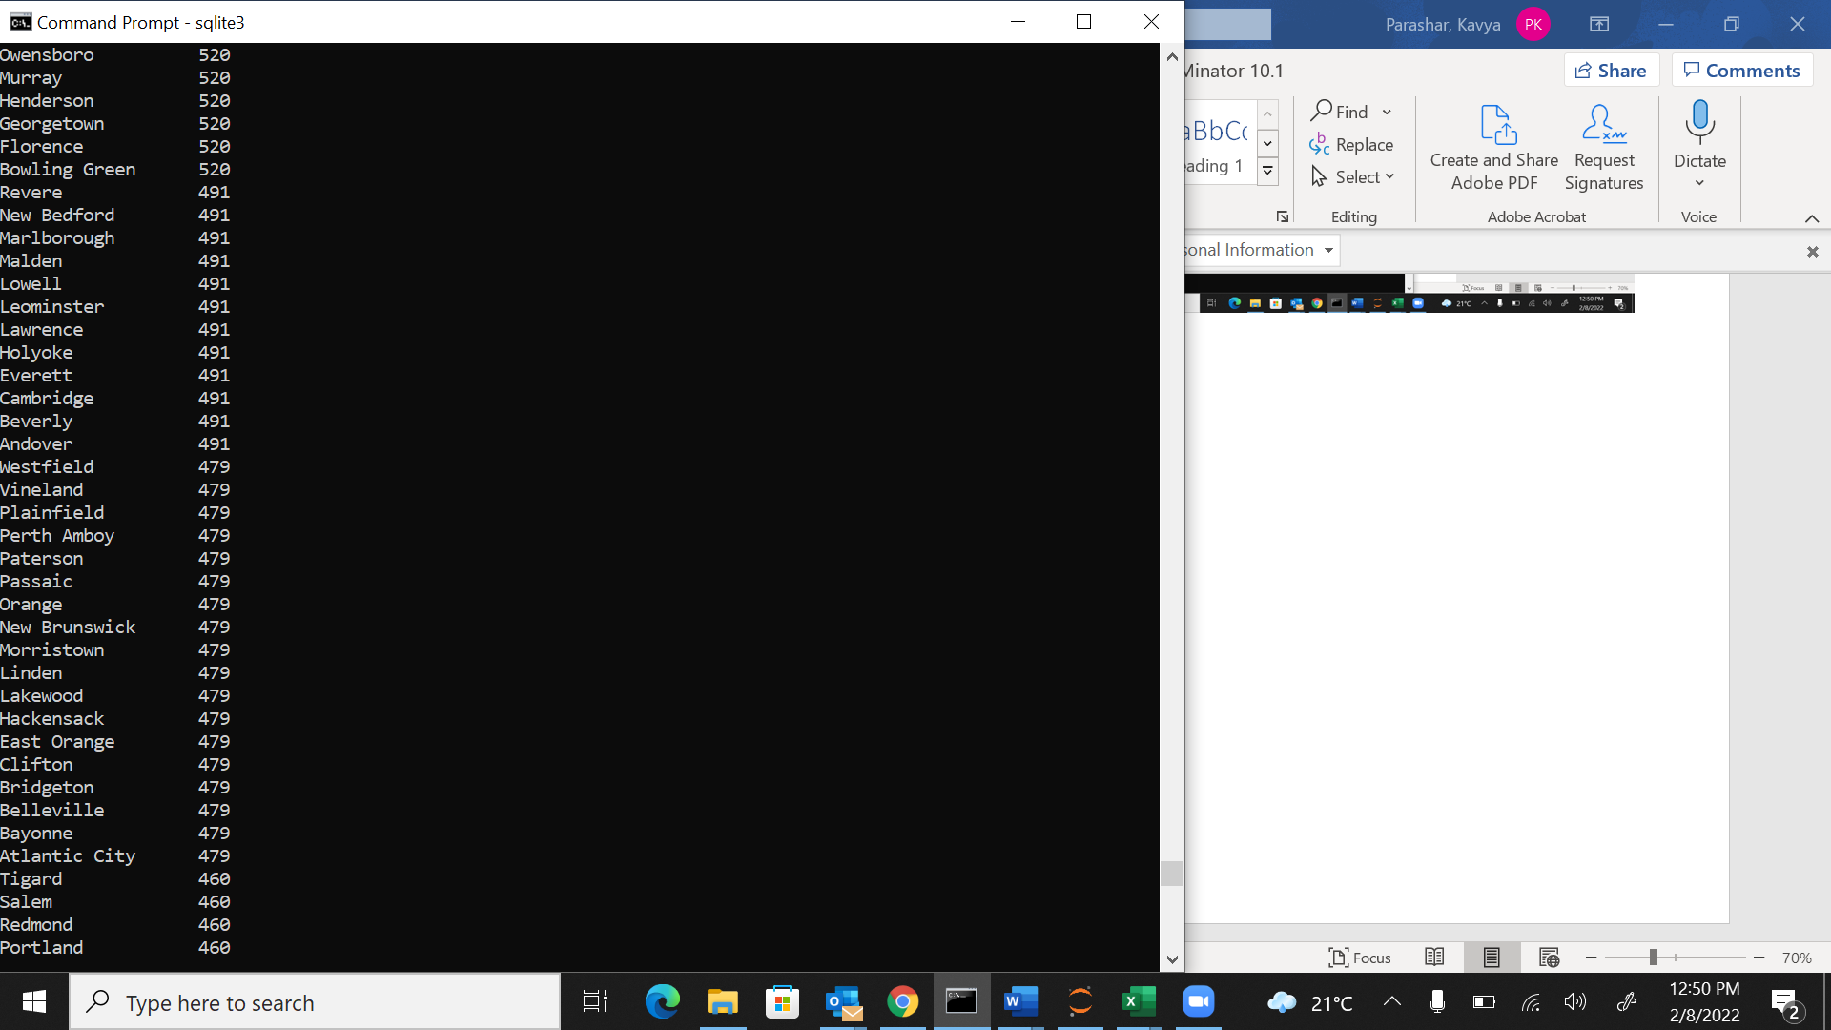

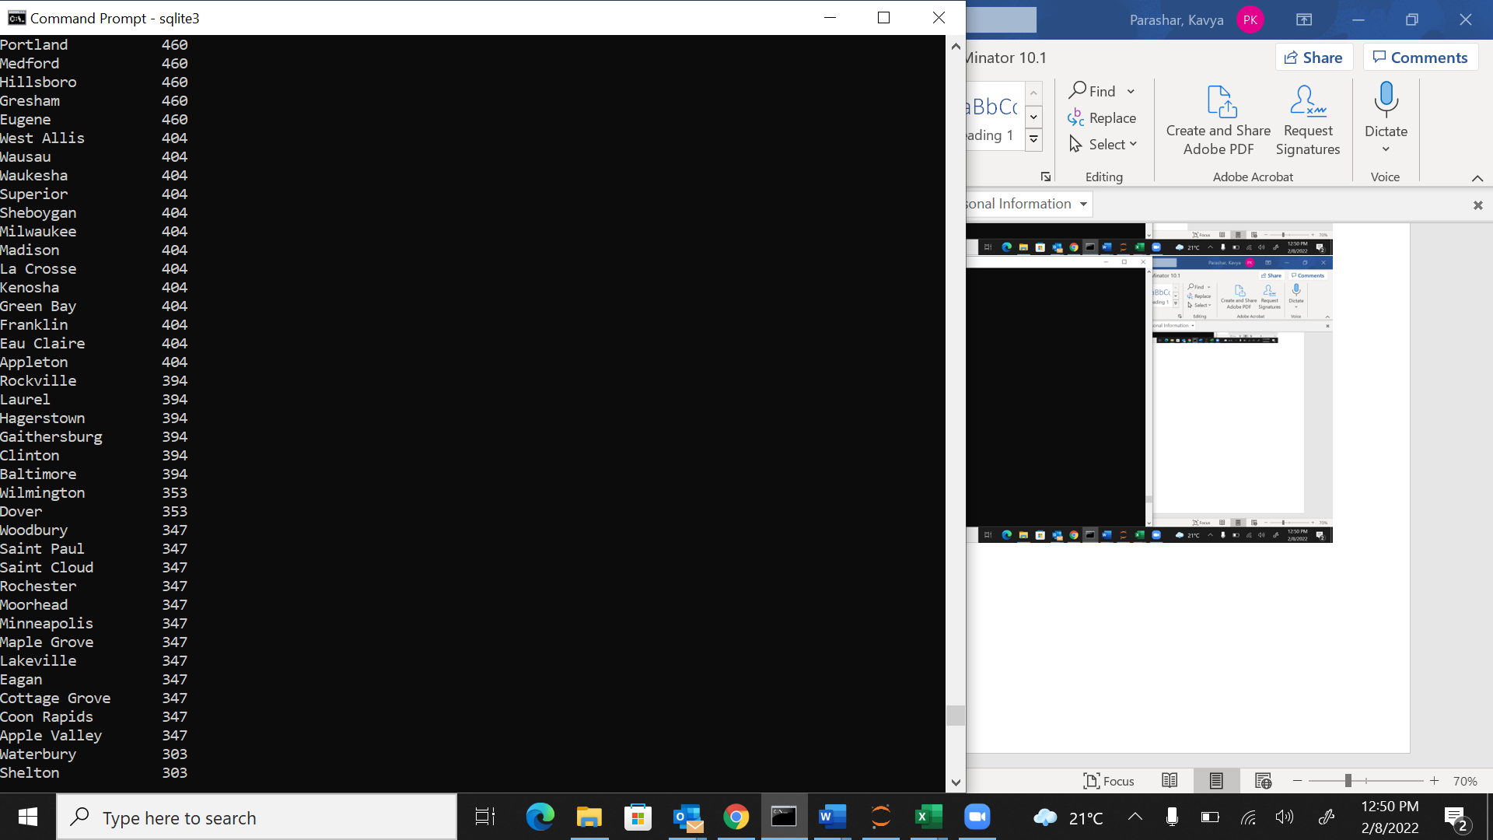

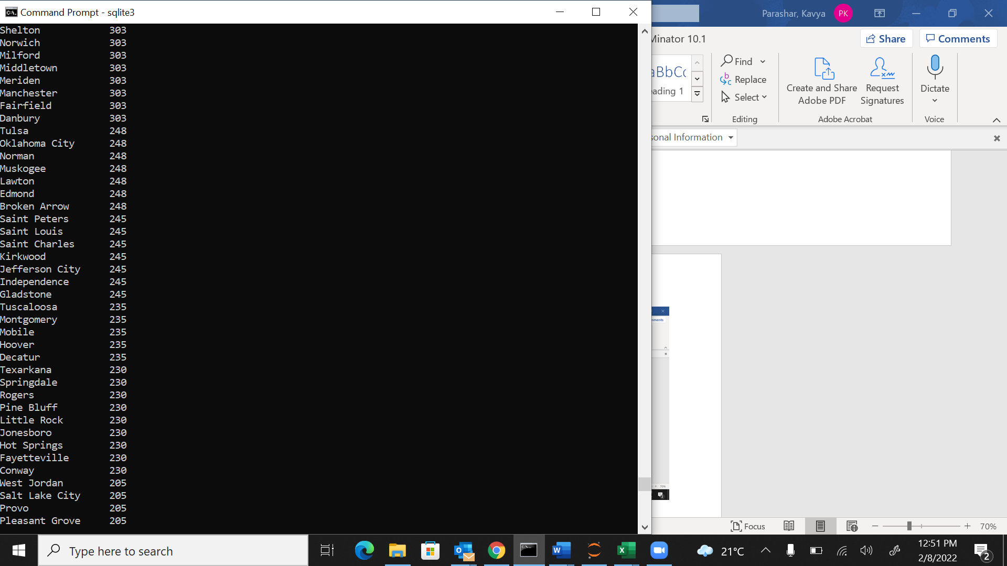

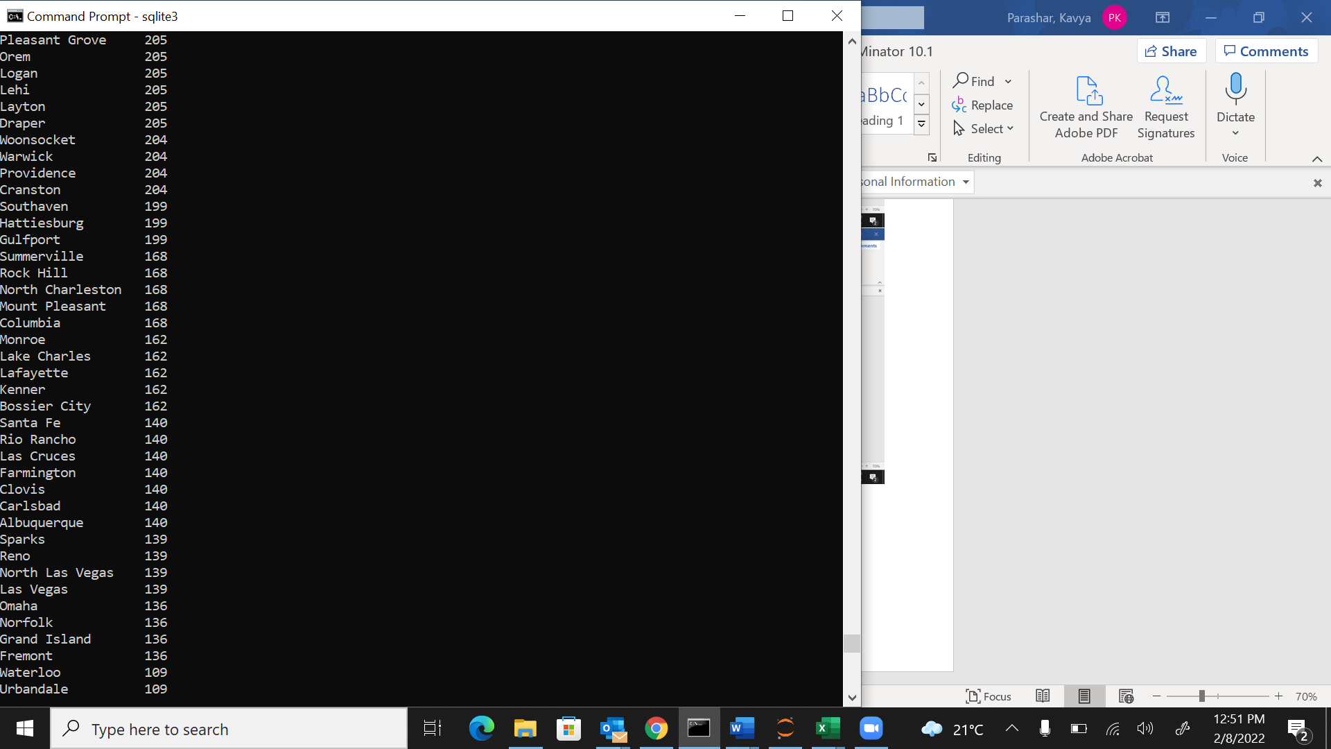

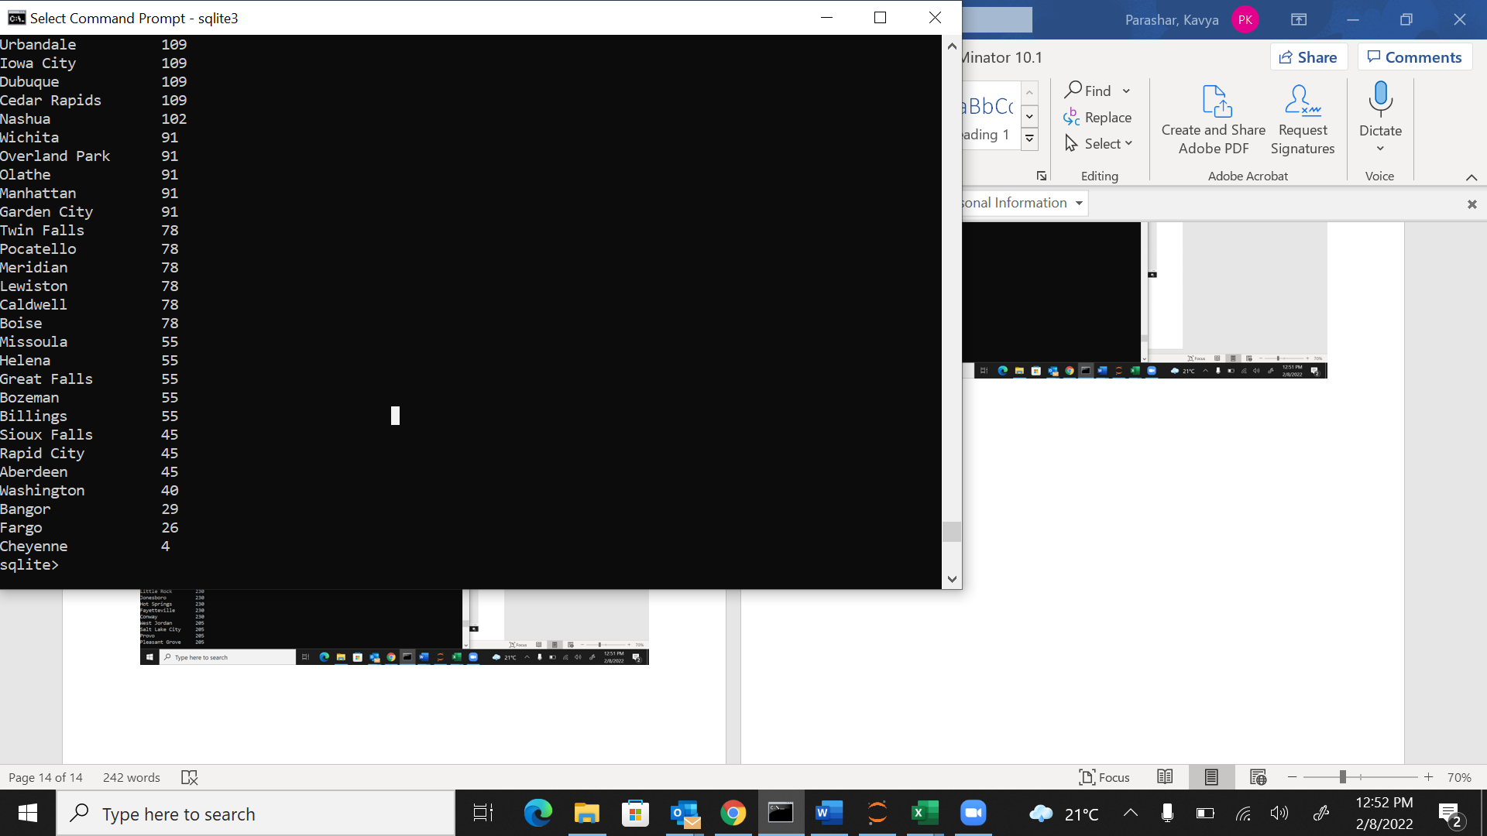

City_Name count(Customer_id)

----------------- ------------------

Yucaipa 7427

Woodland 7427

Whittier 7427

Westminster 7427

Visalia 7427

Vallejo 7427

Vacaville 7427

Torrance 7427

Thousand Oaks 7427

Temecula 7427

Sunnyvale 7427

Stockton 7427

Santa Maria 7427

Santa Clara 7427

Santa Barbara 7427

Santa Ana 7427

San Mateo 7427

San Luis Obispo 7427

San Jose 7427

San Gabriel 7427

San Francisco 7427

San Diego 7427

San Clemente 7427

San Bernardino 7427

Salinas 7427

Sacramento 7427

Roseville 7427

Riverside 7427

Redwood City 7427

Redondo Beach 7427

Redlands 7427

Redding 7427

Rancho Cucamonga 7427

Pomona 7427

Pico Rivera 7427

Pasadena 7427

Oxnard 7427

Ontario 7427

Oakland 7427

Murrieta 7427

Morgan Hill 7427

Moreno Valley 7427

Montebello 7427

Modesto 7427

Mission Viejo 7427

Manteca 7427

Los Angeles 7427

Long Beach 7427

Lodi 7427

Lancaster 7427

Lake Forest 7427

Lake Elsinore 7427

Laguna Niguel 7427

La Quinta 7427

La Mesa 7427

Inglewood 7427

Huntington Beach 7427

Hesperia 7427

Fresno 7427

Escondido 7427

Encinitas 7427

El Cajon 7427

Davis 7427

Danville 7427

Costa Mesa 7427

Coachella 7427

Citrus Heights 7427

Chula Vista 7427

Chico 7427

Camarillo 7427

Burbank 7427

Brentwood 7427

Bakersfield 7427

Antioch 7427

Anaheim 7427

Yonkers 4212

Watertown 4212

Utica 4212

Troy 4212

Rome 4212

Oceanside 4212

Niagara Falls 4212

New York City 4212

New Rochelle 4212

Mount Vernon 4212

Lindenhurst 4212

Jamestown 4212

Hempstead 4212

Freeport 4212

Buffalo 4212

Auburn 4212

Waco 3614

Tyler 3614

The Colony 3614

Texas City 3614

San Marcos 3614

San Antonio 3614

San Angelo 3614

Round Rock 3614

Richardson 3614

Port Arthur 3614

Plano 3614

Pharr 3614

Pearland 3614

Odessa 3614

Missouri City 3614

Mesquite 3614

Mcallen 3614

Mansfield 3614

Lubbock 3614

League City 3614

Laredo 3614

Keller 3614

Irving 3614

Huntsville 3614

Houston 3614

Harlingen 3614

Haltom City 3614

Grapevine 3614

Grand Prairie 3614

Garland 3614

Frisco 3614

Fort Worth 3614

El Paso 3614

Edinburg 3614

Deer Park 3614

Dallas 3614

Corpus Christi 3614

Coppell 3614

Conroe 3614

College Station 3614

Cedar Hill 3614

Carrollton 3614

Bryan 3614

Brownsville 3614

Bedford 3614

Beaumont 3614

Baytown 3614

Austin 3614

Amarillo 3614

Allen 3614

Abilene 3614

York 2180

Reading 2180

Philadelphia 2180

Chester 2180

Bethlehem 2180

Altoona 2180

Allentown 2180

Vancouver 1881

Spokane 1881

Seattle 1881

Renton 1881

Pasco 1881

Olympia 1881

Marysville 1881

Longview 1881

Kent 1881

Edmonds 1881

Des Moines 1881

Covington 1881

Bellingham 1881

Bellevue 1881

Woodstock 1812

Wheeling 1812

Tinley Park 1812

Skokie 1812

Romeoville 1812

Rockford 1812

Quincy 1812

Peoria 1812

Park Ridge 1812

Palatine 1812

Oswego 1812

Orland Park 1812

Oak Park 1812

Normal 1812

Naperville 1812

Highland Park 1812

Glenview 1812

Frankfort 1812

Evanston 1812

Elmhurst 1812

Des Plaines 1812

Chicago 1812

Champaign 1812

Carol Stream 1812

Buffalo Grove 1812

Bolingbrook 1812

Bloomington 1812

Arlington Heights 1812

Toledo 1732

Parma 1732

Newark 1732

Mentor 1732

Medina 1732

Mason 1732

Marion 1732

Lorain 1732

Hamilton 1732

Grove City 1732

Elyria 1732

Dublin 1732

Cuyahoga Falls 1732

Columbus 1732

Cleveland 1732

Cincinnati 1732

Akron 1732

West Palm Beach 1410

Tampa 1410

Tamarac 1410

Tallahassee 1410

Sanford 1410

Saint Petersburg 1410

Port Saint Lucie 1410

Port Orange 1410

Pompano Beach 1410

Plantation 1410

Pensacola 1410

Pembroke Pines 1410

Palm Coast 1410

Ormond Beach 1410

Orlando 1410

North Miami 1410

Miramar 1410

Miami 1410

Melbourne 1410

Margate 1410

Lakeland 1410

Kissimmee 1410

Jupiter 1410

Jacksonville 1410

Homestead 1410

Hollywood 1410

Hialeah 1410

Fort Lauderdale 1410

Deltona 1410

Delray Beach 1410

Daytona Beach 1410

Coral Springs 1410

Coral Gables 1410

Boynton Beach 1410

Boca Raton 1410

Apopka 1410

Westland 959

Trenton 959

Taylor 959

Sterling Heights 959

Saginaw 959

Royal Oak 959

Rochester Hills 959

Midland 959

Lincoln Park 959

Lansing 959

Jackson 959

Holland 959

Grand Rapids 959

Detroit 959

Dearborn Heights 959

Dearborn 959

Canton 959

Ann Arbor 959

Wilson 920

Thomasville 920

Raleigh 920

Hickory 920

Greenville 920

Greensboro 920

Goldsboro 920

Gastonia 920

Durham 920

Concord 920

Charlotte 920

Chapel Hill 920

Cary 920

Burlington 920

Asheville 920

Yuma 844

Tucson 844

Tempe 844

Sierra Vista 844

Scottsdale 844

Phoenix 844

Mesa 844

Glendale 844

Gilbert 844

Chandler 844

Bullhead City 844

Avondale 844

Waynesboro 812

Virginia Beach 812

Suffolk 812

Springfield 812

Newport News 812

Harrisonburg 812

Hampton 812

Chesapeake 812

Charlottesville 812

Arlington 812

Alexandria 812

Warner Robins 692

Smyrna 692

Sandy Springs 692

Roswell 692

Marietta 692

Macon 692

East Point 692

Atlanta 692

Athens 692

Thornton 681

Pueblo 681

Parker 681

Loveland 681

Louisville 681

Longmont 681

Littleton 681

Greeley 681

Fort Collins 681

Englewood 681

Denver 681

Commerce City 681

Colorado Springs 681

Broomfield 681

Aurora 681

Arvada 681

Nashville 658

Murfreesboro 658

Memphis 658

Lebanon 658

Knoxville 658

Johnson City 658

Hendersonville 658

Clarksville 658

Chattanooga 658

Bristol 658

Bartlett 658

South Bend 562

Portage 562

Noblesville 562

New Castle 562

New Albany 562

Mishawaka 562

La Porte 562

Indianapolis 562

Greenwood 562

Elkhart 562

Richmond 520

Owensboro 520

Murray 520

Henderson 520

Georgetown 520

Florence 520

Bowling Green 520

Revere 491

New Bedford 491

Marlborough 491

Malden 491

Lowell 491

Leominster 491

Lawrence 491

Holyoke 491

Everett 491

Cambridge 491

Beverly 491

Andover 491

Westfield 479

Vineland 479

Plainfield 479

Perth Amboy 479

Paterson 479

Passaic 479

Orange 479

New Brunswick 479

Morristown 479

Linden 479

Lakewood 479

Hackensack 479

East Orange 479

Clifton 479

Bridgeton 479

Belleville 479

Bayonne 479

Atlantic City 479

Tigard 460

Salem 460

Redmond 460

Portland 460

Medford 460

Hillsboro 460

Gresham 460

Eugene 460

West Allis 404

Wausau 404

Waukesha 404

Superior 404

Sheboygan 404

Milwaukee 404

Madison 404

La Crosse 404

Kenosha 404

Green Bay 404

Franklin 404

Eau Claire 404

Appleton 404

Rockville 394

Laurel 394

Hagerstown 394

Gaithersburg 394

Clinton 394

Baltimore 394

Wilmington 353

Dover 353

Woodbury 347

Saint Paul 347

Saint Cloud 347

Rochester 347

Moorhead 347

Minneapolis 347

Maple Grove 347

Lakeville 347

Eagan 347

Cottage Grove 347

Coon Rapids 347

Apple Valley 347

Waterbury 303

Shelton 303

Norwich 303

Milford 303

Middletown 303

Meriden 303

Manchester 303

Fairfield 303

Danbury 303

Tulsa 248

Oklahoma City 248

Norman 248

Muskogee 248

Lawton 248

Edmond 248

Broken Arrow 248

Saint Peters 245

Saint Louis 245

Saint Charles 245

Kirkwood 245

Jefferson City 245

Independence 245

Gladstone 245

Tuscaloosa 235

Montgomery 235

Mobile 235

Hoover 235

Decatur 235

Texarkana 230

Springdale 230

Rogers 230

Pine Bluff 230

Little Rock 230

Jonesboro 230

Hot Springs 230

Fayetteville 230

Conway 230

West Jordan 205

Salt Lake City 205

Provo 205

Pleasant Grove 205

Orem 205

Logan 205

Lehi 205

Layton 205

Draper 205

Woonsocket 204

Warwick 204

Providence 204

Cranston 204

Southaven 199

Hattiesburg 199

Gulfport 199

Summerville 168

Rock Hill 168

North Charleston 168

Mount Pleasant 168

Columbia 168

Monroe 162

Lake Charles 162

Lafayette 162

Kenner 162

Bossier City 162

Santa Fe 140

Rio Rancho 140

Las Cruces 140

Farmington 140

Clovis 140

Carlsbad 140

Albuquerque 140

Sparks 139

Reno 139

North Las Vegas 139

Las Vegas 139

Omaha 136

Norfolk 136

Grand Island 136

Fremont 136

Waterloo 109

Urbandale 109

Iowa City 109

Dubuque 109

Cedar Rapids 109

Nashua 102

Wichita 91

Overland Park 91

Olathe 91

Manhattan 91

Garden City 91

Twin Falls 78

Pocatello 78

Meridian 78

Lewiston 78

Caldwell 78

Boise 78

Missoula 55

Helena 55

Great Falls 55

Bozeman 55

Billings 55

Sioux Falls 45

Rapid City 45

Aberdeen 45

Washington 40

Bangor 29

Fargo 26

Cheyenne 4